How to activate Microsoft Office

If someone needs to activate Microsoft Office on the computer by using the Microsoft Toolkit, then the following is the path for that. It is almost the same as the activation of Windows, but there are only one or two steps that differ from that.

**Microsoft Office Activation Steps**

**Step. 01:** First, open the [Microsoft Toolkit](https://mstoolkit.org/download-microsoft-toolkit/).

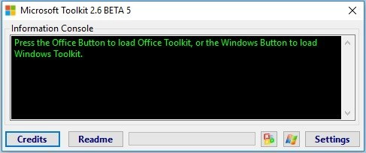

**Step. 02:** Then, click on the **Microsoft Office logo** which is located below the toolkit window.

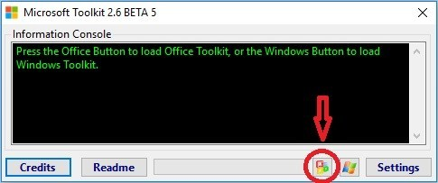

**Step. 03:** Now, you can see a new window pop-up with many options.

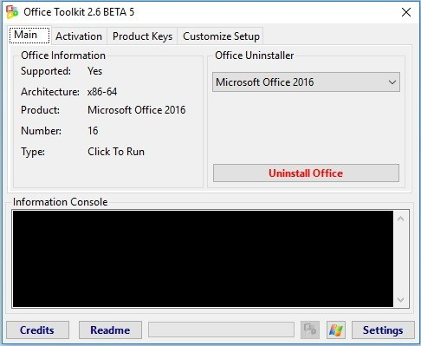

**Step. 04:** Here, activation tab you should click on the **EZ Activator** and wait for a few seconds.

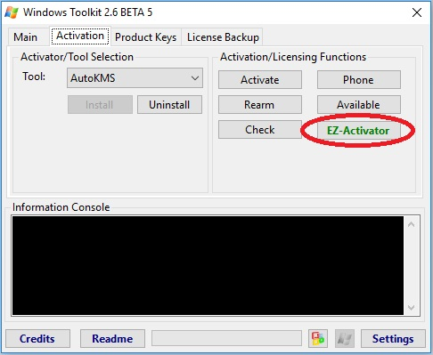

**Step. 05:**After a few seconds, your Microsoft Office activation is completed.

